**Lighting an external LED**

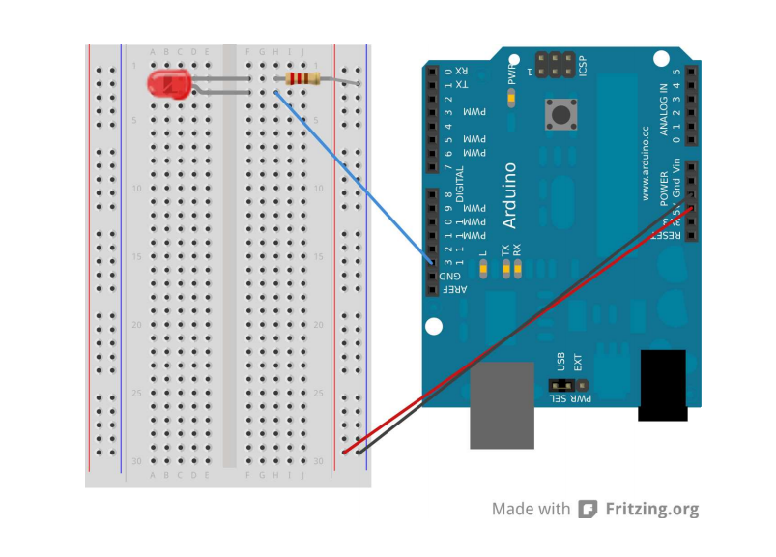

Refer : <http://www.princeton.edu/~ffab/media___downloads_files/IntroArduinoBook.pdf>

Page : 18

Lighting the onboard LED :

Examples : Basics / Blink Example